Building Healthy Communities: Shedding The Yoke of False Dichotomies
In 2016 The California Endowment (TCE) will be celebrating its 20th anniversary as a conversion foundation. 2016 is also the halfway point for TCE’s 10 year Building Healthy Communities initiative, a billion dollar, fourteen site, place-based, health improvement effort targeting comprehensive local and statewide policy and systems change. This year, we are allowing ourselves the luxury of reflecting on our second decade of life as well as endeavoring to share with the field our emerging successes, failures, and learnings to date from Building Healthy Communities (BHC).
BHC is based on the recognition that low income Californians are often shrouded in a thick fog of unremitting chronic stress. Because of a legacy of racial and economic segregation, anti-immigrant policy and a host of other historical “isms’, there are many communities in California where residents are mired in environments that conspire to injure their health. These environments lack basic health protective amenities like parks, grocery stores, decent schools, functioning transportation systems, affordable and decent housing, living wage jobs, and even potable water in some instances. In these environments, community residents are forced to constantly navigate multiple risks without the benefit of significant resources. These neighborhood and community environments are not natural, they are manmade, and can be unmade. Building Healthy Communities is an effort that enlists the very residents that have been the targets of exclusion, stigma, and discrimination in remaking their environments through holding local, regional and state systems accountable for creating healthy and equitable community environments. The BHC theory of change is about building community capacity (increasing social, political and economic power and changing the narrative about health), to change policy and systems, in order to create healthy environments, that will (over time) improve health status. The targeted policy and systems change is multi-level: local, regional, and statewide. BHC is particularly focused on improving the social and health outcomes of populations that have been under threat such as Boys and Men of Color (BMOC) and consequently BHC has a special focus on strategies that enhance opportunity structures for BMOC.
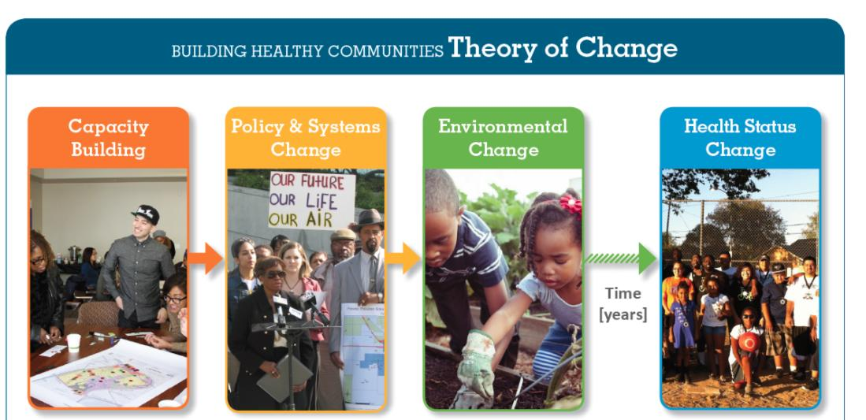
Community-driven vs. Foundation driven.
The field of comprehensive community change initiatives (CCIs) is rife with false dichotomies. One of the most persistent is this notion that an initiative is either community-driven or foundation-driven. When we started BHC, we crafted a set of 10 health outcomes that we believed represented the basic constellation of community health issues that conspire to plague many low income communities. Our theory was that one could not have a healthy neighborhood environment without supportive policy and systems in these 10 core domains. We are a health foundation and naturally our primary focus was on health outcomes. However, early in our interaction with community partners when we shared our 10 outcomes and the theory behind BHC we began to hear about challenges that young people were facing in the school system, particularly African American boys and other boys of color. Suspensions, expulsions, ticketing and arrests were a constant feature of the school experience for many young people in our BHC school districts. Our work in schools had traditionally been about healthy school lunches, getting sugar sweetened beverages out, increasing school PE, community-school joint-use agreements, and enhancing school-based health centers and related services. School discipline was not on our radar screen. Despite this, our community partners persisted and helped us better understand the role that so-called zero tolerance policies were having on the social and emotional health of young people. We knew that education is a critical social determinant of health and a key part of the opportunity structure for low income youth. So we faced a dilemma. If this was a community-driven initiative, we needed to regroup and begin exploring the whole domain of school discipline and its health impacts and design a grant-making strategy to help our partners bring about appropriate policy change. If this was a foundation-driven initiative we needed to gracefully let our partners know that school discipline was beyond the scope of BHC and perhaps introduce them to other funders who might have an interest in this issue.
Other new issues had also arisen during the course of our conversations with community partners including minimum wage, immigration reform, community policing, affordable housing, childcare access and preschool, predatory lending, gentrification, prison reform, the drought, and of course jobs. As a health funder that recognizes the fundamental role of the social determinants of health, how are we to work with our partners to select issues to prioritize in the BHC initiative? Community-driven or foundation-driven; our evaluators strongly implied that we had to choose, otherwise we risked confusing our partners and irreparably damaging the initiative’s decision-making processes. The school discipline decision teed up this issue directly for us. We had to decide.
The first step was to better understand the school discipline issue. Data released from the Office for Civil Rights (OCR) at the US Department of Education revealed that more than 400,000 students were suspended out-of-school at least one time during the 2009-10 school year in California. That’s enough students suspended to fill every seat in all the professional baseball and football stadiums in the state. Across California, nearly 1 out of every 5 African American students (18%), 1 in 9 American Indian students (11%), and 1 in 14 Latino students (7%) in the state sample were suspended at least once in 2009-10, compared to 1 in 17 white students (6%) and 1 in 33 Asian American students (3%). Since the 1970s the suspension rates for black youth has increased double the rate of that for white students. In districts with the highest suspension rates in the state, just under a quarter of the entire student body—nearly one of every four students of all races and ages—received at least one suspension in a school year. A student suspended from school misses learning time, is left unsupervised, and has an increased risk of dropping out and becoming involved in the juvenile justice system. Being suspended even once in ninth grade is associated with a twofold increase in the likelihood of dropping out of high school. Our community partners were right.
For over 15 years, forward-thinking parents in various parts of the state had been fighting to turn the tide against the growing use of suspension, expulsion and policing practices that fall under the broad rubric of zero tolerance. While important headway was made in individual districts, the issue of school discipline remained largely invisible to most state policymakers. In 2011 we decided to get involved.
We began by making grants to long-term campaigns focused on school discipline in four of the BHC sites, Oakland, Los Angeles, Fresno and Long Beach. In concert with our partners, TCE created an unprecedented statewide coalition comprised of grassroots community and youth organizers from BHC sites, legal advocates, academic researchers, and statewide policy advocates. Our statewide Alliance for Boys and Men of Color adopted school discipline as a key priority and TCE supported the creation of a Senate Select Committee on the Status of Boys and Men of Color which conducted regional hearings throughout the state in which BHC youth testified about the personal consequences of overly harsh school discipline policies. Additionally, TCE commissioned a firm to do a statewide poll of attitudes toward discipline reform to raise awareness and validate the importance of school discipline as an important education policy issue in California. Polls showed that four out of five voters in California support changes in the discipline system and nine in ten voters back a preventive approach to discipline.
In the 2011-12 legislative session, ten school discipline bills were introduced into the California legislature, seven passed, and five were signed into law. Since 2009-10, out of school suspensions have declined by almost 40 percent.
The Building Healthy Communities initiative is not “community-driven” nor is it “foundation-driven”. It is a dialectic, a constant dialogue and negotiation between equal partners seeking the most promising path towards the truth. A key lesson learned for us is to have no fixed agendas and no hidden agendas. As a health foundation that seeks to prevent adverse health outcomes and eliminate health disparities, we have our sights focused on the social determinants of health equity. Our community partners have wisdom and expertise about how those determinants are manifesting in their daily lives. By listening to this experience and having the humility and good sense to modify our foundation agenda, we were able to participate in profound and measurable change in opportunity for vulnerable young people across the state and help positively shift their life trajectory and reduce health and social inequity.

Dr. Tony Iton
Senior VP, Healthy Communities
The California Endowment

